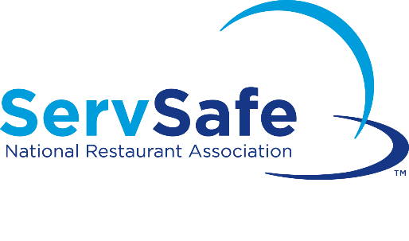
SERVSAFE CLASS REGISTRATION FORM
Class Date: January 30, 2019
Registration Deadline: January 7, 2019

This course is primarily to certify managers and will require a written examination. A certificate will be issued upon satisfactory completion of the course and will be valid for (5) years. Registration is complete when your form & fee are received by our office. Your textbook will be provided at registration and should be reviewed prior to class attendance. Should you have any questions, please feel free to call (910) 592-4675 or email Jason Royal at jasonroyal@sampsonnc.com.
STUDENT INFORMATION
Name:
Mailing Address:
City: |  | State: |  | Zip:
Email: |  | Phone:
EMPLOYER INFORMATION
Name of Facility:
Mailing Address:
City: |  |  | State: |  | Zip:
Phone: | Fax:
PLEASE SELECT A LANGUAGE PREFERENCE FOR PRINTED MATERIALS:
Textbook: English_____ Spanish_____
Exam: English_____ Spanish_____ Chinese_____ Japanese_____ Korean_____
Time: 8 AM to 5:30 PM (Full Course)
3:30 PM to 5:30 PM (Test only)
Location: Sampson County Health Department (2nd Floor Conference Room)
360 County Complex Rd.
Clinton, NC 28328
Phone: (910) 592-4675 Fax: (910) 592-2874

FEE: (check only one) ______Full Course (Includes all materials needed) $ 181.00
______Full Course (Bring your own 7th Edition ServSafe book) $ 116.00
______Re-test/Test Only (exam sheet included) $ 56.00
Please make checks payable to: Sampson County Health Department and deliver or mail your completed registration form to the address above. OR you may fax your completed form to (910) 592-2874 and call our office to make a payment over the phone using your credit/debit card.

(For office use only) Date Paid: _________________ Receipt #:_________________

